PARKING for HILLEL AT UCLA:

Please park at UCLA Lot #2 – located at Hilgard & Westholme – across from the street from Hillel ($8 per car).

Effective 7:30 pm the kiosk/cashier at this entrance is not manned, but guests may still enter the Lot – by proceeding south of Westholme (i.e. enter Lot just north of Manning) – where there are self-operated pay machines which take cash and credit cards.

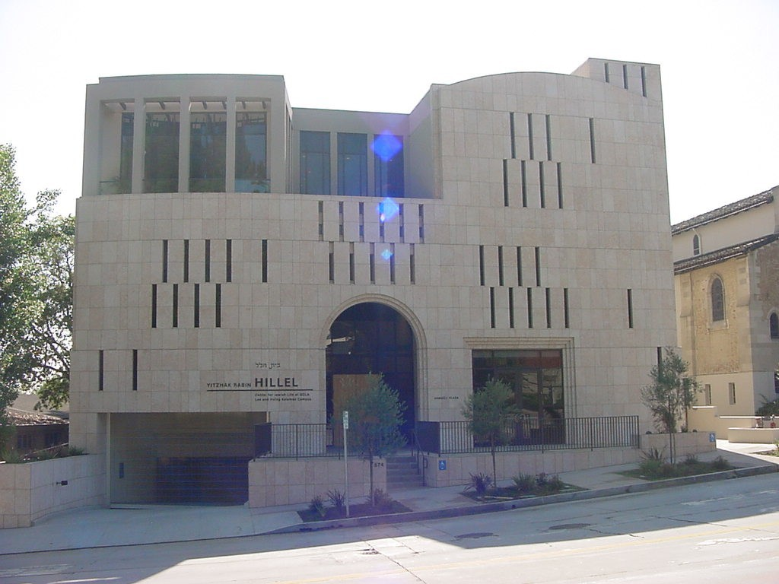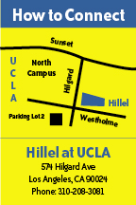  Important: parking is not available at Hillel or on the surrounding neighborhood streets. (No parking on Strathmore Drive or 600 block of Westholme.) | Hillel at UCLA, at 574 Hilgard Avenue, is approximately five blocks south of Sunset Boulevard and two major lights west of Beverly Glen – across the street from UCLA at Westholme.  Directions from the south: from Wilshire Blvd. head north on Westwood Blvd., turn right (east) on Le Conte – then left (north) on Hilgard.

